- After installing JDK and checking the version in the command prompt using commands ‘java -version’ & ‘javac –version’, I get an error: “java is not recognized as an internal or external command”. Error screenshot shown below:
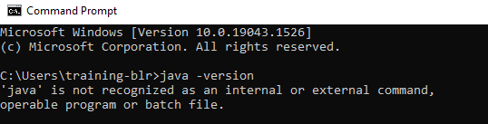

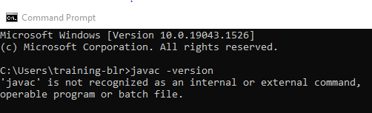

Answer: It needs to be added to PATH in Environment variables
Open Environment variables window, by clicking the windows start button, and type “Environment variables”
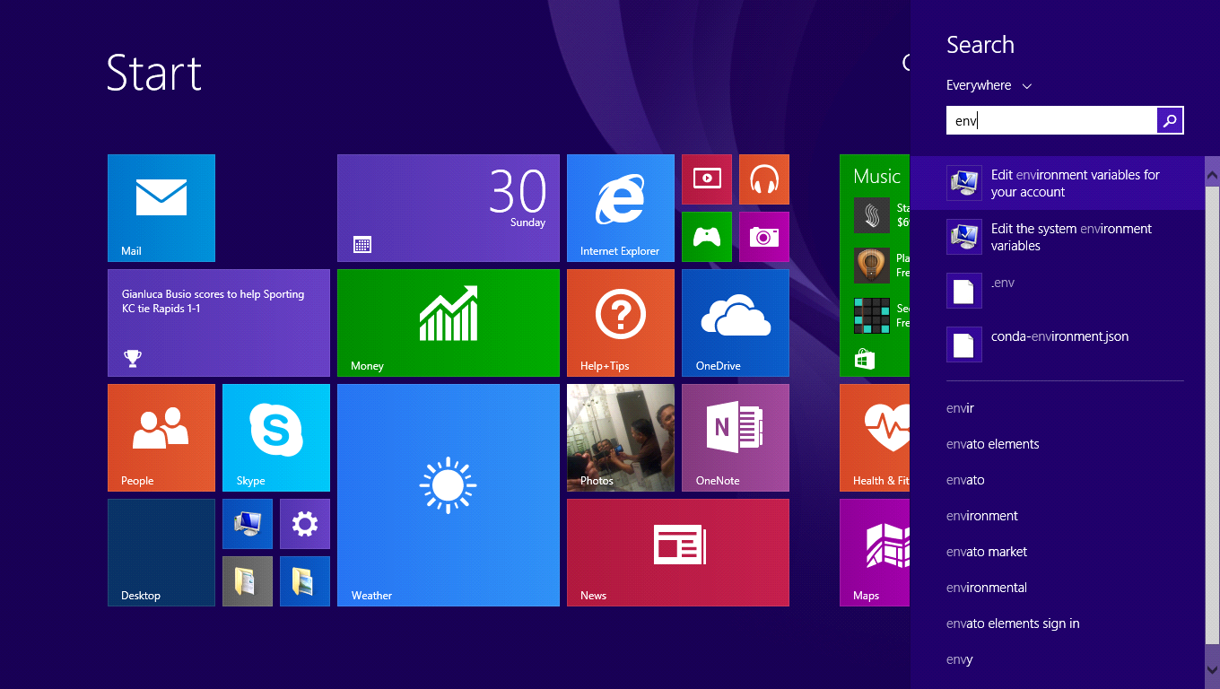
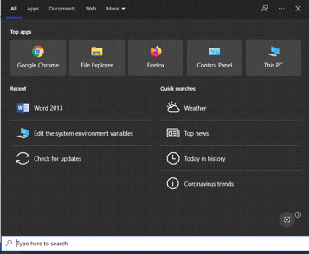

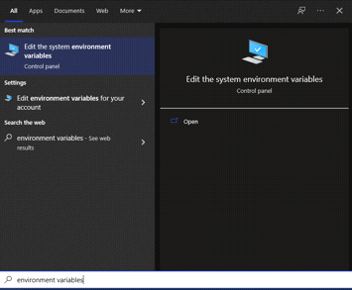

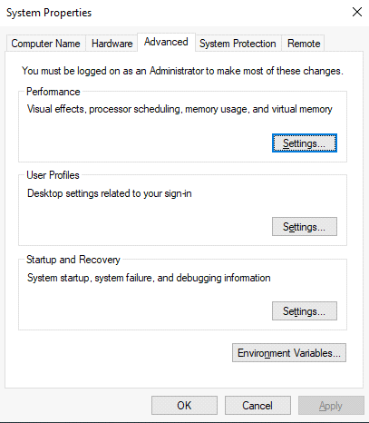
Click on ‘Environment Variables’
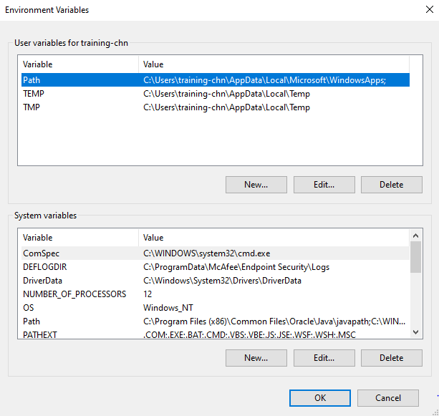

Search PATH in “User variables” section.
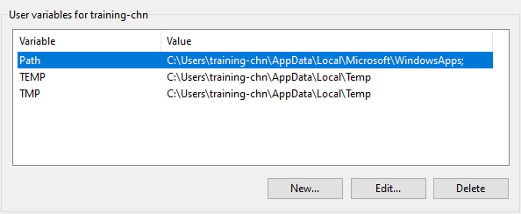Select “PATH” and then click on ‘Edit’, next screenshot shown below
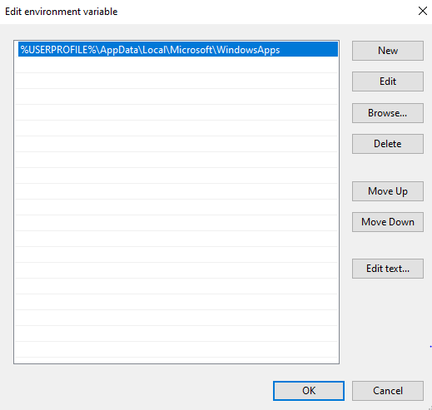

Click on ‘New’
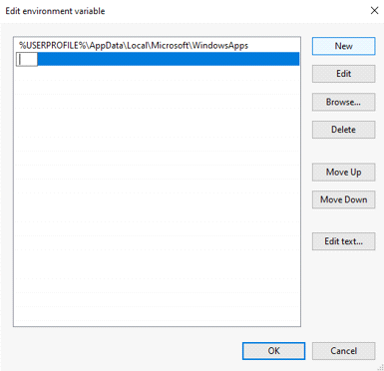
Copy and paste the JDK installation folder path i.e. ‘C:\Program Files\Java\jdk1.8.0_321\bin’

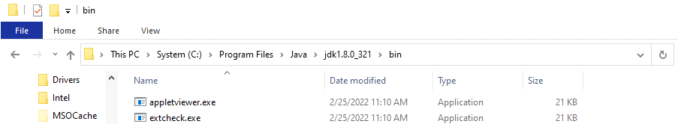

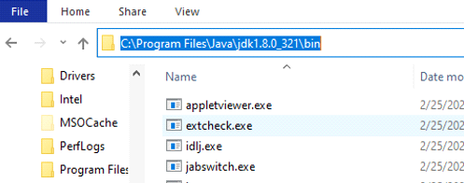

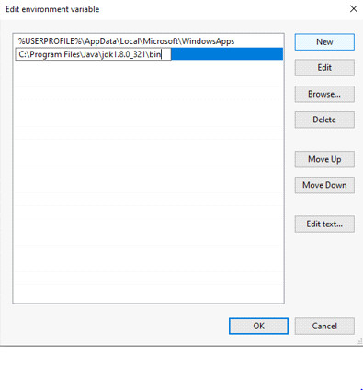
Then click on ‘OK’
Do the same for “System variables” section.
Search and click on ‘Path’
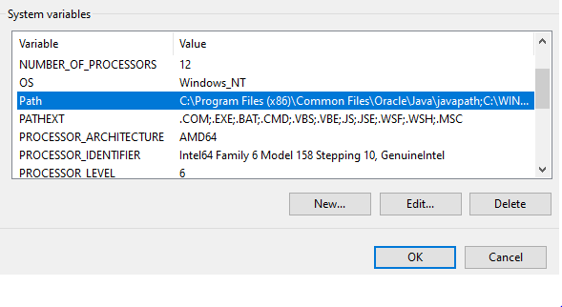
Click on ‘Edit’
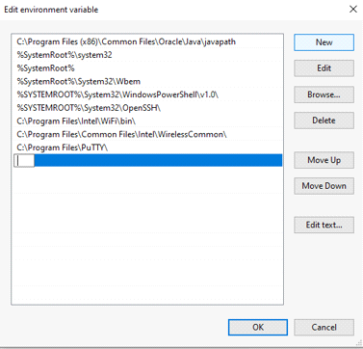
Copy and paste the JDK installation folder path i.e. ‘C:\Program Files\Java\jdk1.8.0_321\bin’
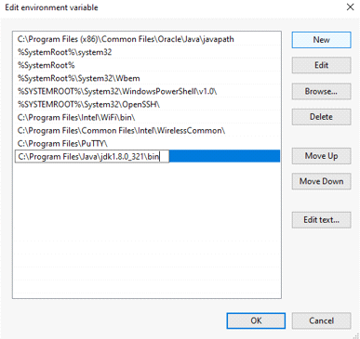
Then click on ‘OK’
Note: This setting won't work in the already opened terminal window (cmd)
So, open a new terminal window by issuing "cmd" and then check "java -version"
Go to windows terminal ‘cmd’ and run the commands
‘java –version’ & ‘javac –version’ to check the version of Java installed.
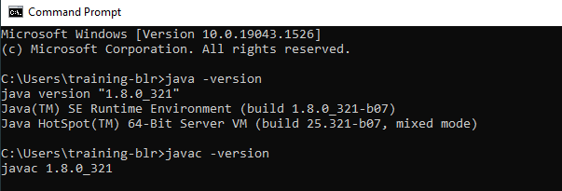

- When working remotely, not able to download certain software’s by using the VPN and due to firewall restrictions.
Answer: Download the software’s by using open internet access (by disconnecting VPN).

Unable to install the VM image in Oracle Virtual Box software. Getting the below error:

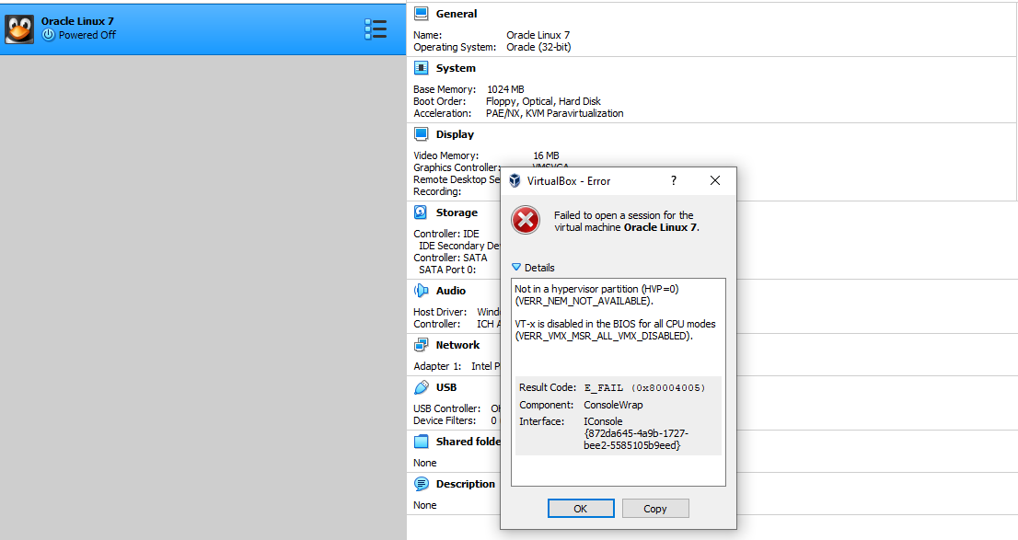
Answer: Check if virtualization is enabled in the BIOS as the above error is because of Virtualization option disabled in the BIOS.
To check this do the below steps:
Go to Run – type ‘cmd’ – type ‘systeminfo.exe’
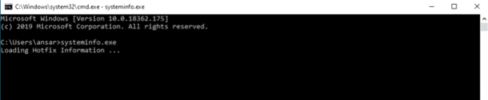
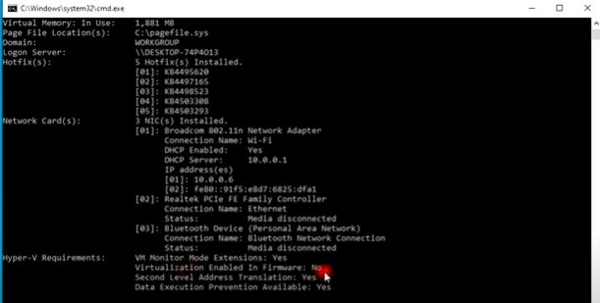

If ‘Virtualization enable in firmware’ shows “No’ as shown above,

then we have to enable the virtualization option in the BIOS.

To Enable Virtualization in System BIOS (UEFI in modern Systems), there are 2 methods:-
1st Method:
- Close All the running applications and Go to Start Menu
- Press and HOLD ‘SHIFT’ key while clicking “Restart” button.
NOTE: After Windows began restarting leave ‘SHIFT’ key.
- Wait for Windows to show a full screen menu with choices:
Choose “Troubleshoot”
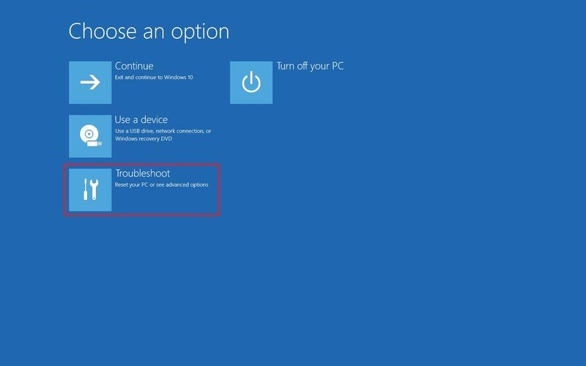
- Click on “Advanced options”


- Click “UEFI Firmware Settings”
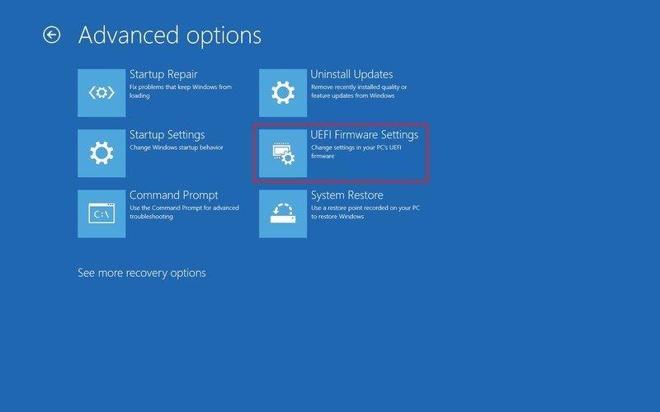

- Now, proceed to restart
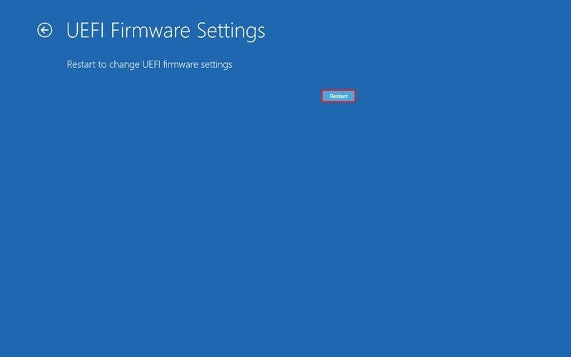

- Once you are inside BIOS/UEFI Setup screen, look out for Virtualization and Enable it.
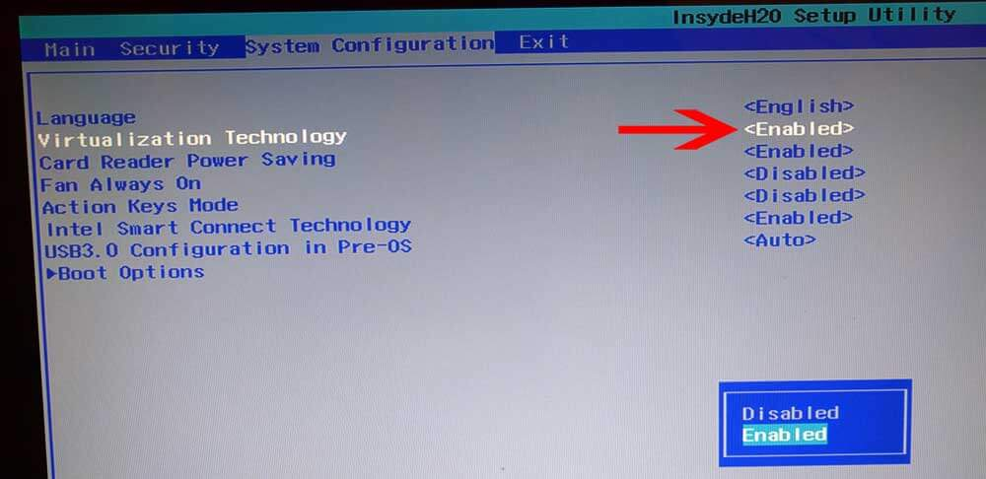
OR in some laptops select Advanced Tab & then select VT-x & VT-d option in Virtualization Tab...

Then Proceed to Save and Exit.

OR
2nd Method:
How to Enable Virtualization on system.
- Power off your computer.
- Then press the specific hotkey to enter BIOS. The hotkeys may vary due to different brands. It usually is Esc, F2 or Del, etc.
Iii. Then navigate to the Advanced tab, press Enter to continue.
- Select Virtualization and enable it OR select VT-x & VT-d option in Virtualization Tab.
- After that, save the changes and reboot your computer.

- How to increase the System Base memory in the VM image installed in Oracle Virtual Box for faster booting of the VM image.
Answer: Verify the amount of System Base Memory allocated to the VM.
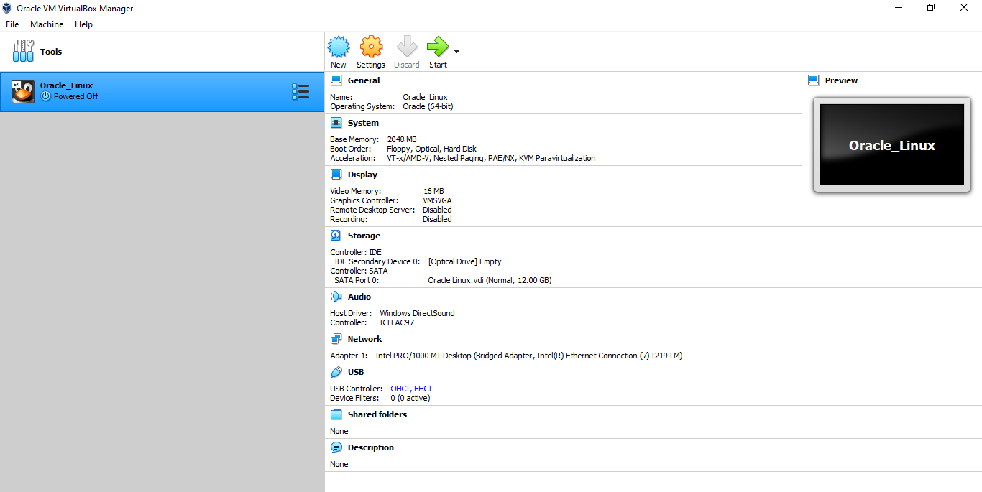

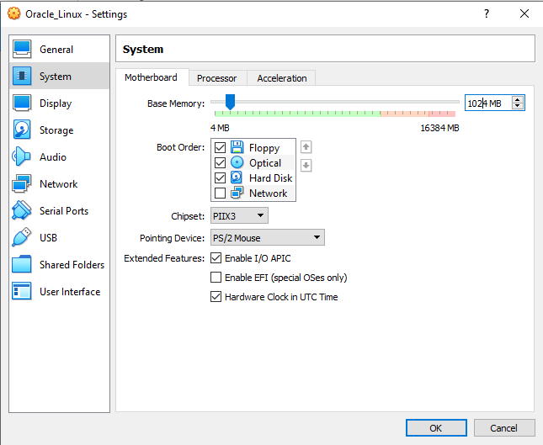

To boot the oracle Linux VM faster increase the base memory from 1024MB to 2048MB.
